// Project 1, API Project by Raman Srivastava

Note\* In order to TEST this program, the user must go to <https://webchat.freenode.net/> and join the #irchacks channel along with any valid username.

Note\*\* The console ONLY displays the status of the server, it CANNOT be used to interact with the chatbot as a user. A user can quit the chatbot and the program by typing “quit” in the console.

Note\*\*\* The functions supported by the chatbot currently are:

-Inputting “time”, which displays current time,

-Inputting “Weather XXXXX” where it displays the weather status for a Zip code or a City.

-Inputting “Check email XXXXX”, where the inputted email is checked to see if it’s valid (if it can respond to SMTP).

-Inputting “Check number XXXXX”, where the inputted number is checked to see if it’s valid. Note that the Country Code is required, such as “1XXXXXXXXXX” for U.S. phone numbers.

-Inputting “help”, which displays all of the normal commands described above.

-Inputting “quit”, which is a hidden command that allows the bot to be disconnected from the Freenode server.

Note\*\*\*\* For the Zip code or City, it MUST be in the U.S.

Note\*\*\*\*\* Used the GSON and pircbot libraries in addition to Java’s default libraries.

Own Test Cases:

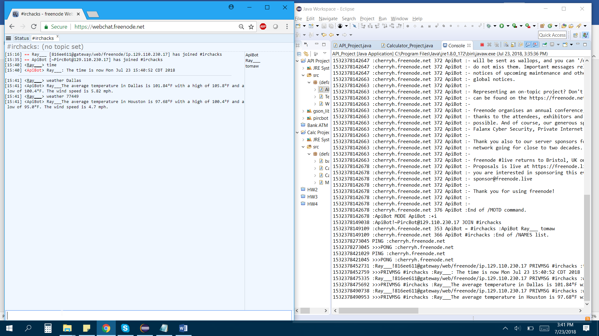

<https://i.imgur.com/oFTSY5k.jpg>

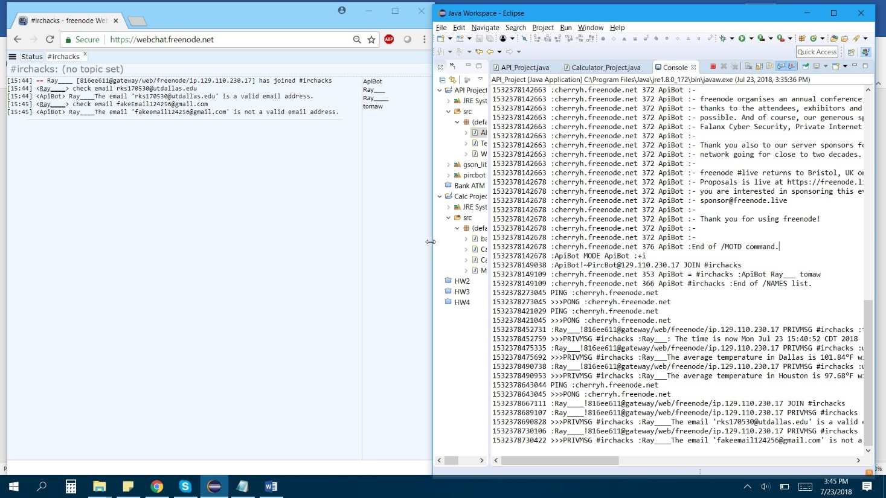

<https://i.imgur.com/y7jY7ov.jpg>

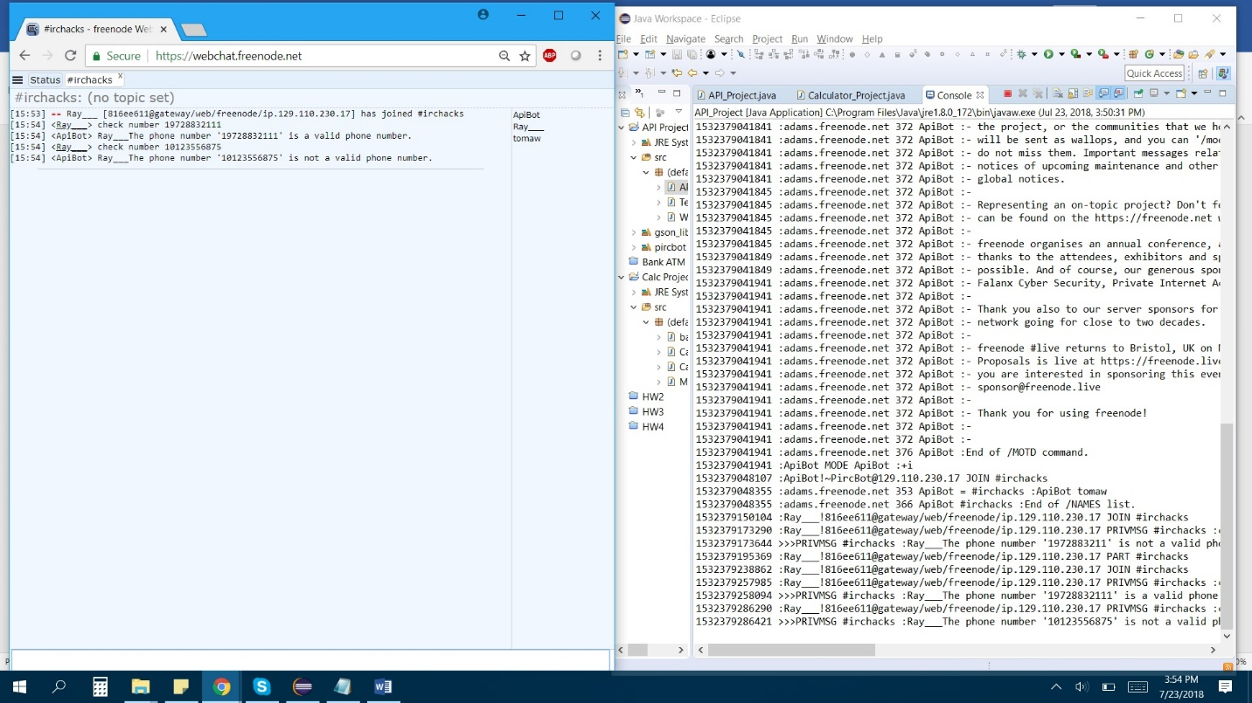

<https://i.imgur.com/Ti5HMxd.jpg>

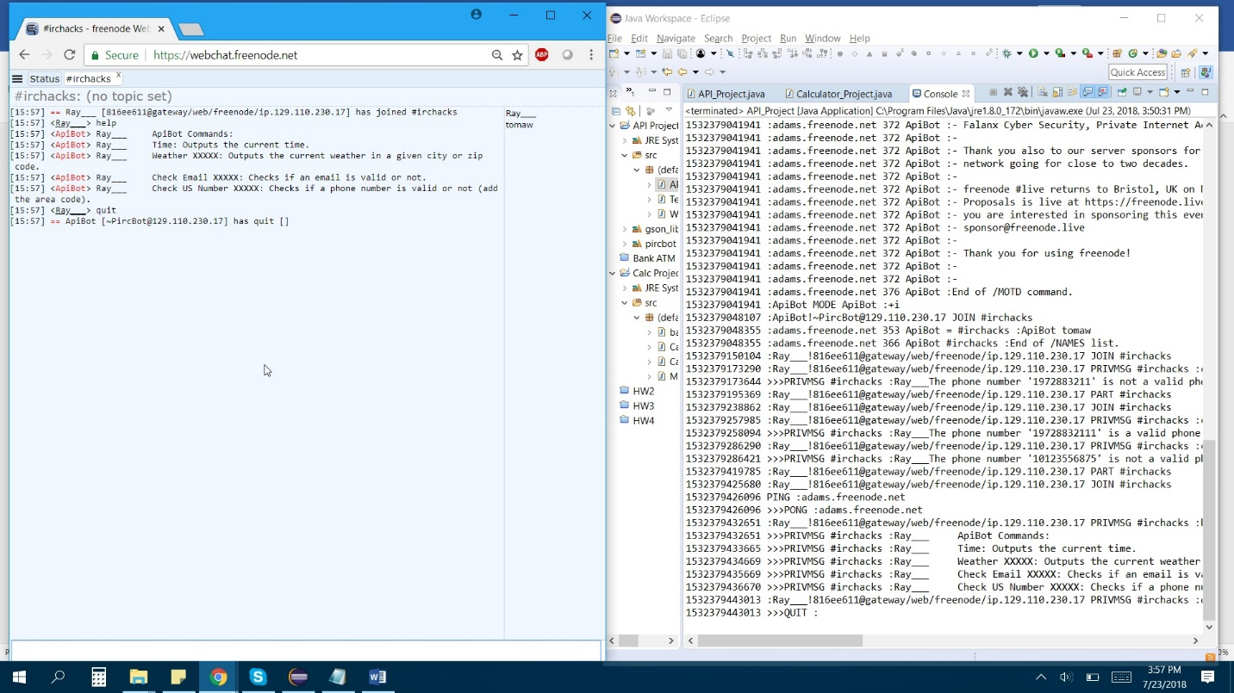

<https://i.imgur.com/1R4ZqUk.jpg>